Here is the setup.

You’re a backend developer and you need to write a code that outputs an integer, a multiple of 10, between 0 & 100 given a rational number as input, a number between 0 & 1.

Purpose: That number is used to reference a css rule used to generate a graphic that represents a sliding rating bar (see image below). An example of input would be 0.8333 and your code needs to output 80.

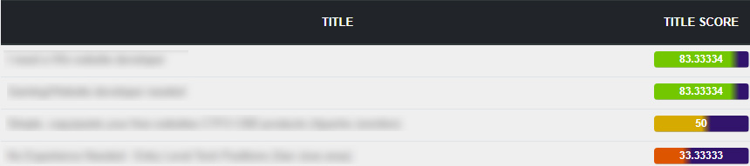

**Rules for code**

Your code needs to output one of the following whole numbers: 10, 20, .. ,.90, and 100 given the following.

1. I need to be able to enter in a rational whole number between 0 & 1.
2. Your should produce two bits of code implementing:
   1. An **IF** or **Switch** statement (whichever you prefer).
   2. Your own elegant solution that uses a single line to produce the output.
      1. Meaning, an If and switch statement uses multiple lines of conditional test to produce a result. This same operation can be done on a single line and you need to find that solution.

NOTE: you cannot create a function and call it from a single line. There is a built in mechanism that allows you to produce the same result that the IF or Switch statement generates.

1. For all methods the following inputs should generate the respective outputs:
   1. 0.14 outputs 10
   2. 0.15 outputs 20
   3. 0.41 outputs 40
   4. 0.49 outputs 50

Notice that the hundredth decimal place determines which direction on the number line to go. A hundredth place greater than or equal to 5 and less than or equal to 9 produce an output that moves right on the number line, while a hundredth place less than or equal to 4 or greater than or equal to 0 produces an output that moves left on the number line.